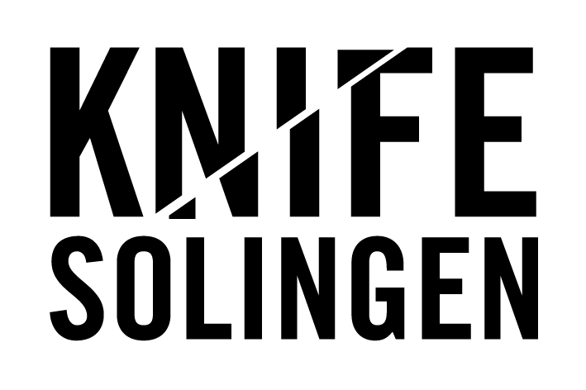
KNIFE 2025
Application and Participation Terms

§1 General Conditions
(1) KNIFE 2025 – the Blade Fair in Solingen – is a sales fair for high-quality knives and blades (handcrafted one-of-a-kind pieces, small series, and production models), as well as tools and materials for knife making, and literature on the subject.
(2) The fair will take place on October 25 and 26, 2025, at the Theater and Concert Hall in Solingen.
(3) The organizer of KNIFE 2025 is the Deutsches Klingenmuseum Solingen (hereinafter referred to as the “Organizer”).
(4) The fair showcases individual manufacturers, not retail or second-hand trade.
(5) Tables/booths may not be shared by multiple exhibitors.
§2 Application and Acceptance Procedure
(1) Applications for participation must be submitted via an online form.
(2) Submission of the application is binding.
(3) The Organizer reserves the right to accept or reject applications in coordination with the German Knifemakers Guild and the Industrial Association for Cutlery and Household Goods.
(4) Participation becomes effective upon acceptance of the application by the Organizer.
(5) Approved participants will be listed in the exhibitor directory (both online and printed).
(6) There is no legal entitlement to participate.

§3 Payment
(1) Participation fees are listed at www.knife-solingen.de.
(2) Accepted participants will receive an invoice for the participation fee (via email). Payment is due within two weeks of the invoice date.
(3) Withdrawal from the registration is possible free of charge until January 31, 2024. After that date, no refunds will be made. Any fee already incurred remains payable.

§4 Communication
(1) Communication from the Organizer to participants will be conducted via email or phone.

§5 Prohibited Goods
(1) Exhibitors are obliged to comply with the provisions of the Washington Convention on International Trade in Endangered Species (WA/CITES) regarding the trade and sale of ivory, tortoiseshell, etc.
(2) All goods must comply with German weapons law (e.g., no balisongs, no OTF switchblades, no knuckle dusters, no sword canes or other concealed weapons).
(3) The Organizer reserves the right to exclude exhibitors from KNIFE 2025 whose goods do not meet the above criteria or are deemed to damage the reputation of the Organizer or the event (e.g., use of extremist symbols). No claim for refund or compensation arises from such exclusion.

§6 Venue, Access, Opening Hours
(1) Exhibitors may access the venue on Friday, October 24, 2025, from 2:00 PM to 6:00 PM for booth/table setup.
On Saturday, October 25, 2025, access for exhibitors begins at 8:00 AM. The fair is open to the public from 10:00 AM to 6:00 PM.
On Sunday, October 26, 2025, access for exhibitors again begins at 8:00 AM. The fair is open to the public from 10:00 AM to 4:00 PM.
(2) Tables/booths must remain staffed until the end of public visiting hours on both days.
(3) All areas of the venue are strictly non-smoking zones.
(4) Dogs and other pets are not permitted inside the building.
(5) Alcohol is not permitted at the venue.

§7 Insurance
(1) The Organizer holds general liability insurance for KNIFE. All other risks (accidents, theft, etc.) are the sole responsibility of the exhibitors.

If you have any questions about the application and participation terms, please contact:
KNIFE
Deutsches Klingenmuseum Solingen
Email: knife@solingen.de
Phone: +49 212 25836-10

